Lab-5 Computer Network Design using HUB in GNS3

Q1) Design network configuration shown in Figure 5.29 for all parts. Connect all four VMs to a single Ethernet segment via a single hub as shown in Figure 5.29. Configure the IP addresses for the PCs as shown in Table 6.1.
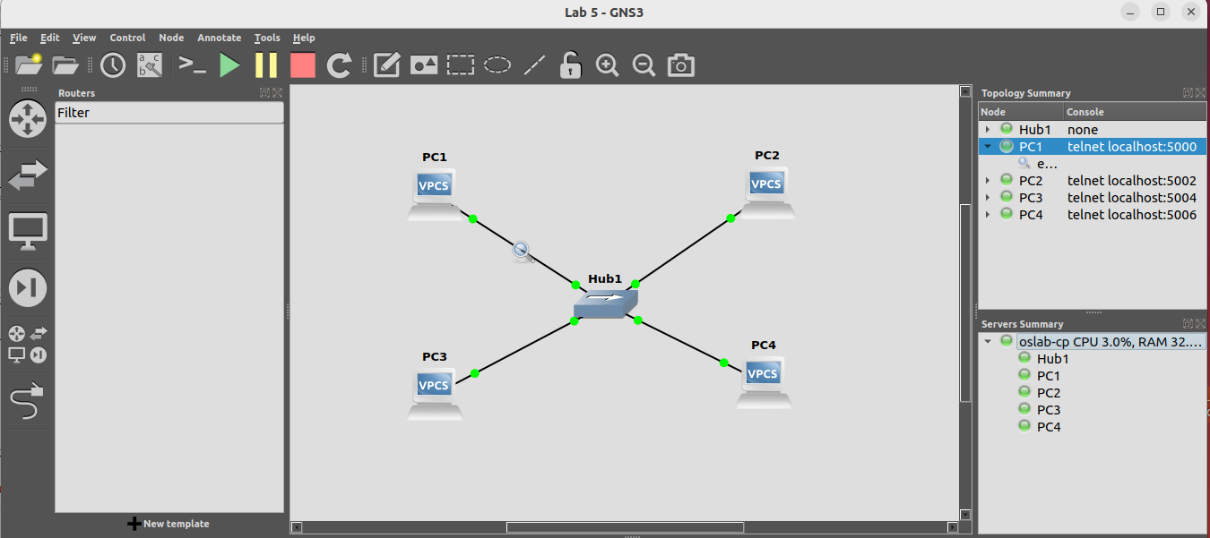

a. On PC1, view the ARP cache with show arp
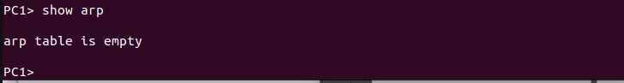
b.Start Wireshark on PC1-Hub1 link with a capture filter set to the IP address of PC2.
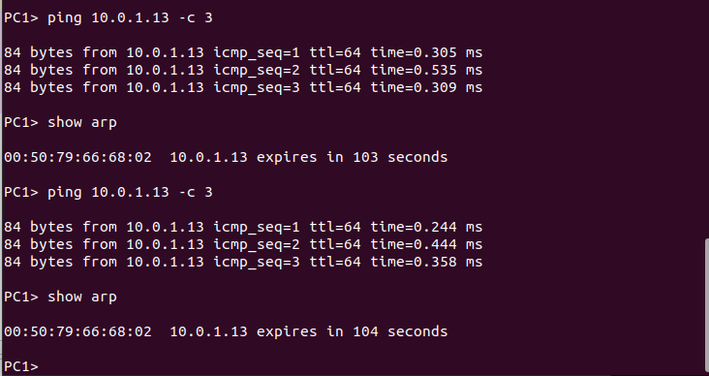

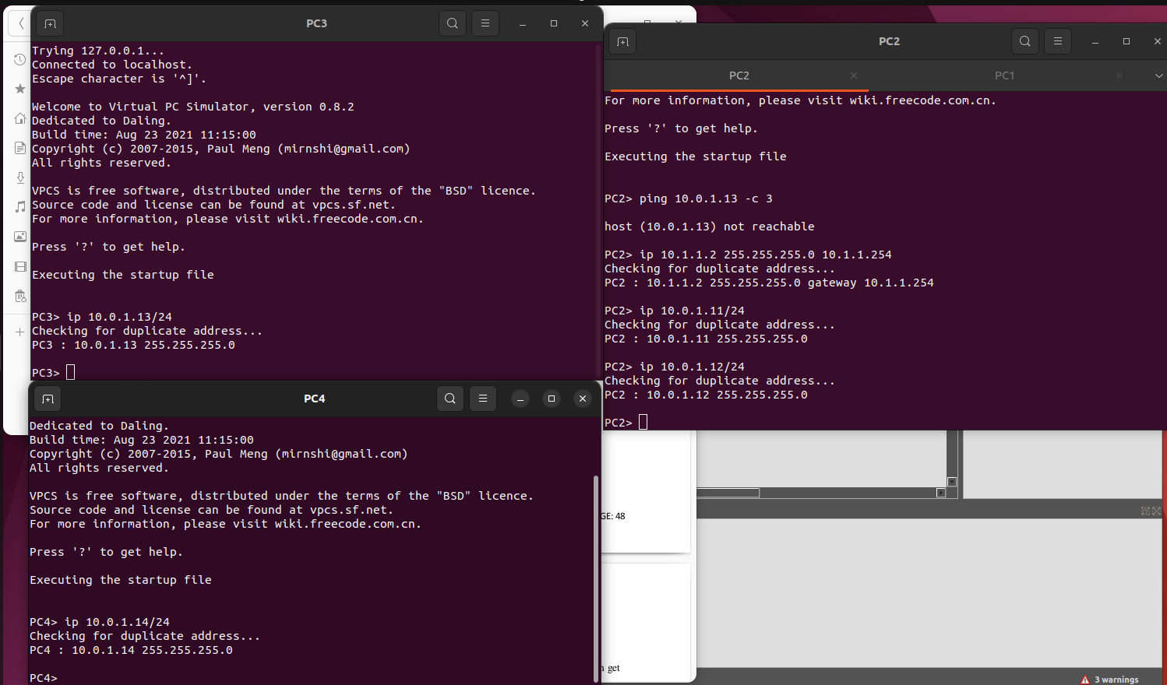
Filtered all the ips of the PC1,PC2,PC3 and PC4.

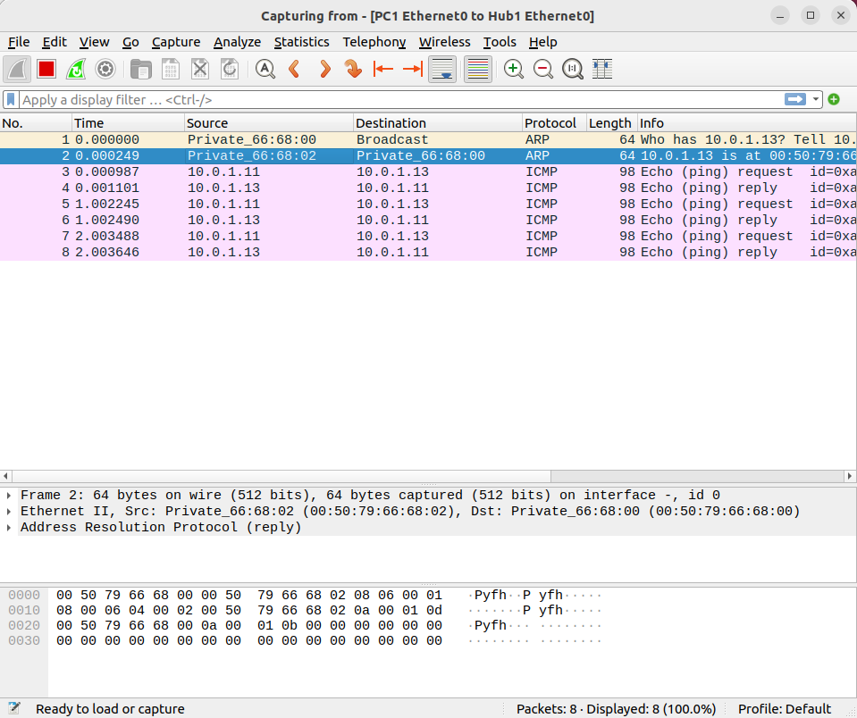

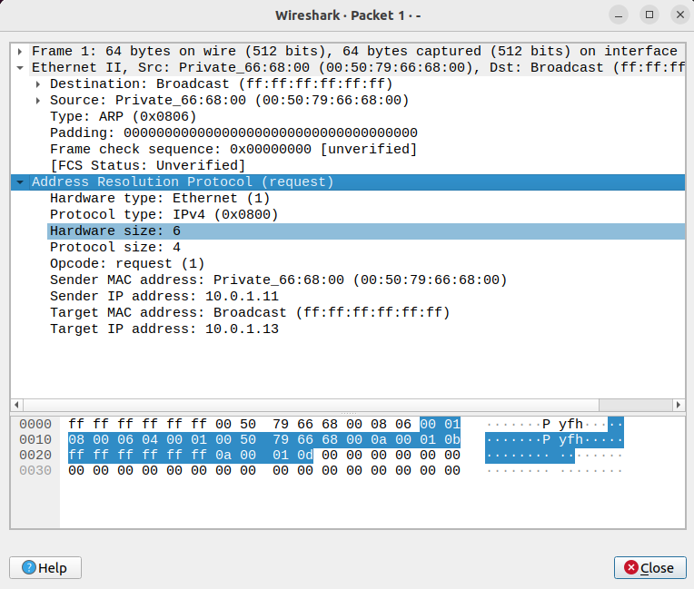

Q3) To test the effects of changing the netmask of a network configuration.
a. Design the configuration as Exercise 1 and replace the hub with a switch, two hosts (PC2and PC4) have been assigned different network prefixes.
Setup the interfaces of the hosts as follows:
VPCS IP Address of eth0 Network Mask
PC110.0.1.100 / 24255.255.255.0
PC210.0.1.101 / 28255.255.255.240
PC310.0.1.120 / 24255.255.255.0
PC410.0.1.121 / 28255.255.255.240
PC1->


PC2->


PC3->


PC4->

b. Run Wireshark on PC1-Hub1 link and capture the packets for the following scenarios. c) d)...
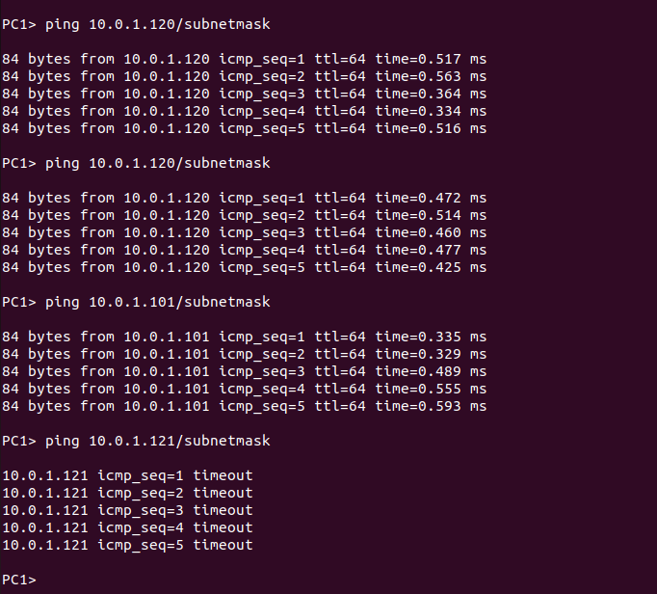
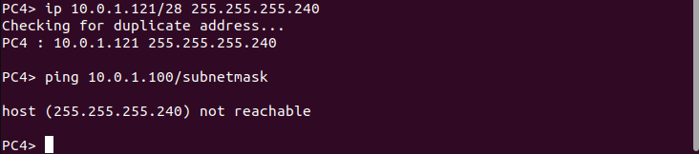

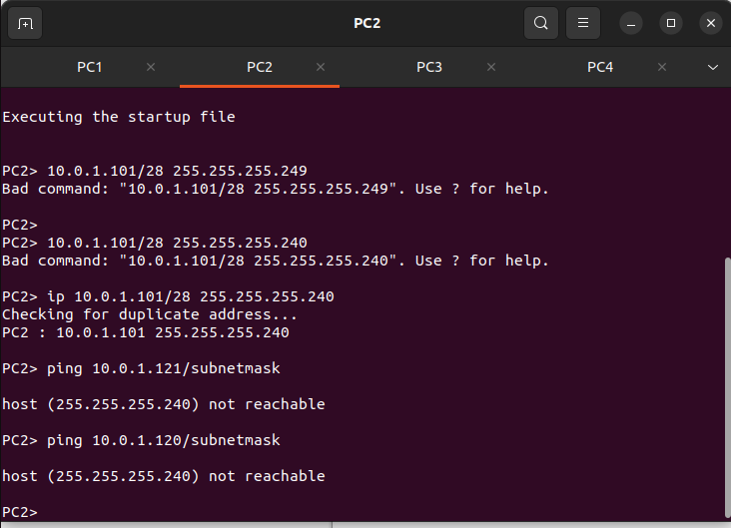

VII. EXERCISES
Based On Lab Question 1
• What is the destination MAC address of an ARP Request packet?

Ans)-Ethernet II, Src: Private_66:68:00 (00:50:79:66:68:00), Dst: Broadcast (ff:ff:ff:ff:ff:ff)

• What are the different Type Field values in the Ethernet headers that you observed?

Ans)-Some common Ethernet Type Field values along with their corresponding protocols:

1. Pv4:Type Field value 0x0800
This indicates that the payload of the Ethernet frame contains an IPv4 packet.

2. ARP (Address Resolution Protocol):Type Field value 0x0806
This indicates that the payload of the Ethernet frame contains an ARP packet.

3. IPv6:Type Field value 0x86DD
This indicates that the payload of the Ethernet frame contains an IPv6 packet.

• Use the captured data to analyze the process in which ARP acquires the MAC address for IP
address 10.0.1.12.
Ans)-
1. ARP Request:When a device (let's call it Device A) wants to communicate with another device (Device B) with IP address 10.0.1.12, and it doesn't know Device B's MAC address, it sends an ARP Request packet. The ARP Request packet contains Device A's MAC address, IP address, and a target IP address of 10.0.1.12.

2. Broadcast:Since Device A doesn't know the MAC address of Device B, it sends the ARP Request packet as a broadcast to all devices on the local network segment. The destination MAC address of this Ethernet frame is the broadcast MAC address (FF:FF:FF:FF:FF:FF).

3. Capture Traffic:Using a network capturing tool like Wireshark, you can capture the network traffic on the relevant network segment. Look for ARP Request packets with the source IP address of Device A and a target IP address of 10.0.1.12.

4. Device B's Response:If Device B is on the same network segment and has IP address 10.0.1.12, it recognizes its IP address in the ARP Request packet. Device B responds with an ARP Reply packet containing its MAC address.

5. Capture ARP Reply:Capture the ARP Reply packet with the MAC address of Device B in the network capturing tool.

Based On Lab Question 3
Explaination of all questions and output got form ping commands

Ans)-PC1 can ping PC3 because the first 24 bits of both IP address match.
PC1 can ping PC2 because the first 24 bits of both IP address match.
PC1 can ping PC4 because the first 24 bits of both IP address match.
PC4 cannot ping PC1 because the first 28 bits of the two IP addresses do not match.
PC2 cannot ping PC4 because the first 28 bits of the two IP addresses do not match.
PC2 cannot ping PC3 because the first 28 bits of the two IP addresses do not match.

